POSTMAN:

GET:

A GET request is used to obtain details from the server and does not have any impact on the server. The GET request does not update any server data while it is triggered. The server only sends its Response to the request.

>steps to create a GET request in Postman −

**Step 1** − Click on the New menu from the Postman application and select Request.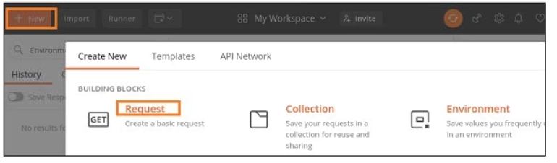

**Step 2** − SAVE REQUEST pop-up comes up. Enter the Request name then click on Save.

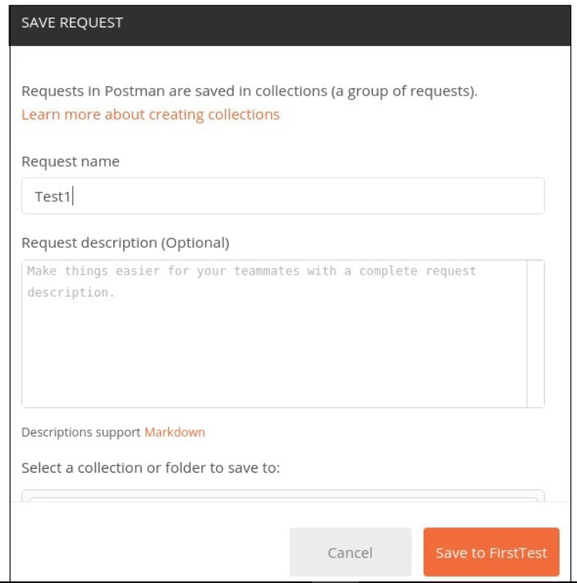

**Step 3** − The **Request name (Test1)** gets reflected on the Request tab. We shall then select the option **GET** from the HTTP request dropdown.

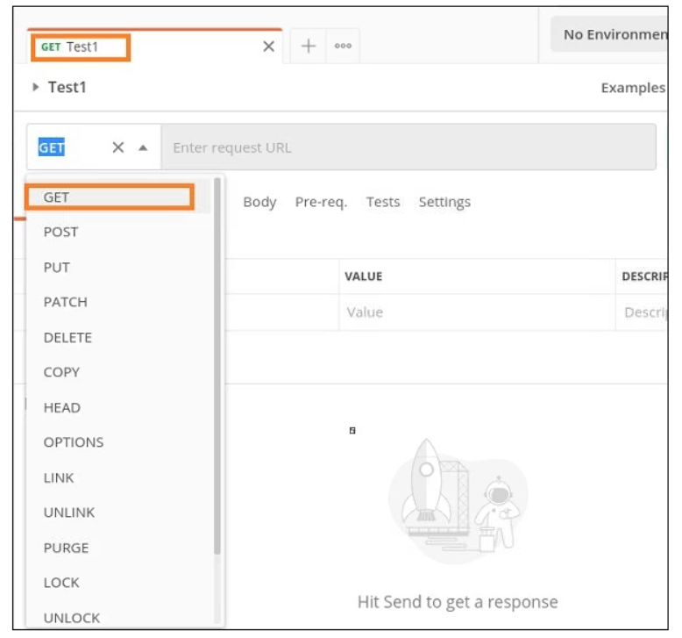

**Step 4** − Enter an URL - <https://www.tutorialspoint.com/index.htm> in the address bar and click on Send.

Once a request has been sent, we can see the response code **200 OK** populated in the Response. This signifies a successful request and a correct endpoint.

